# --------------------------- elastic_net_regression_20240111-142515 -----------------------

Pre-predictions:

timestamp percentage_current rainfall_current

0 2023-03-06 07:05:00 0.102151 0.0

1 2023-03-06 07:10:00 0.232222 0.0

2 2023-03-06 07:15:00 0.382500 0.0

3 2023-03-06 07:20:00 0.546497 0.0

4 2023-03-06 07:25:00 0.720643 0.0

5 2023-03-06 07:30:00 0.903331 0.0

6 2023-03-06 07:35:00 1.091661 0.0

7 2023-03-06 07:40:00 1.283641 0.0

8 2023-03-06 07:45:00 1.478930 0.0

9 2023-03-06 07:50:00 1.676373 0.0

10 2023-03-06 07:55:00 1.876199 0.0

Metrics for this specific prediction:

Accuracy: 99.97%

Mean squared error: 0.2872492600109897

Variance (R²) score: 1.00

# ------------------------------ lasso_regression_20240111-142331 ----------------------------

Pre-predictions:

timestamp percentage_current rainfall_current

0 2023-03-06 07:05:00 0.101607 0.0

1 2023-03-06 07:10:00 0.231409 0.0

2 2023-03-06 07:15:00 0.381463 0.0

3 2023-03-06 07:20:00 0.545255 0.0

4 2023-03-06 07:25:00 0.719215 0.0

5 2023-03-06 07:30:00 0.901749 0.0

6 2023-03-06 07:35:00 1.089954 0.0

7 2023-03-06 07:40:00 1.281827 0.0

8 2023-03-06 07:45:00 1.476995 0.0

9 2023-03-06 07:50:00 1.674314 0.0

10 2023-03-06 07:55:00 1.873995 0.0

Metrics for this specific prediction:

Accuracy: 99.97%

Mean squared error: 0.285613727868308

Variance (R²) score: 1.00

# ------------------------------- linear_regression_20240111-141009 --------------------------

Pre-predictions:

timestamp percentage_current rainfall_current

0 2023-03-06 07:05:00 0.096178 0.0

1 2023-03-06 07:10:00 0.224423 0.0

2 2023-03-06 07:15:00 0.375160 0.0

3 2023-03-06 07:20:00 0.539307 0.0

4 2023-03-06 07:25:00 0.712475 0.0

5 2023-03-06 07:30:00 0.895162 0.0

6 2023-03-06 07:35:00 1.084348 0.0

7 2023-03-06 07:40:00 1.276773 0.0

8 2023-03-06 07:45:00 1.473152 0.0

9 2023-03-06 07:50:00 1.670603 0.0

10 2023-03-06 07:55:00 1.870541 0.0

Metrics for this specific prediction:

Accuracy: 99.97%

Mean squared error: 0.26566816855873493

Variance (R²) score: 1.00

# ------------------------------------ poly_2_20240111-135443 -----------------------------------

Pre-predictions:

timestamp percentage_current rainfall_current

0 2023-03-06 07:05:00 0.057345 0.0

1 2023-03-06 07:10:00 0.187864 0.0

2 2023-03-06 07:15:00 0.412486 0.0

3 2023-03-06 07:20:00 0.751328 0.0

4 2023-03-06 07:25:00 1.223046 0.0

5 2023-03-06 07:30:00 1.852210 0.0

6 2023-03-06 07:35:00 2.654652 0.0

7 2023-03-06 07:40:00 3.635768 0.0

8 2023-03-06 07:45:00 4.792946 0.0

9 2023-03-06 07:50:00 6.119190 0.0

10 2023-03-06 07:55:00 7.597041 0.0

Metrics for this specific prediction:

Accuracy: 99.98%

Mean squared error: 0.21334431255963318

Variance (R²) score: 1.00

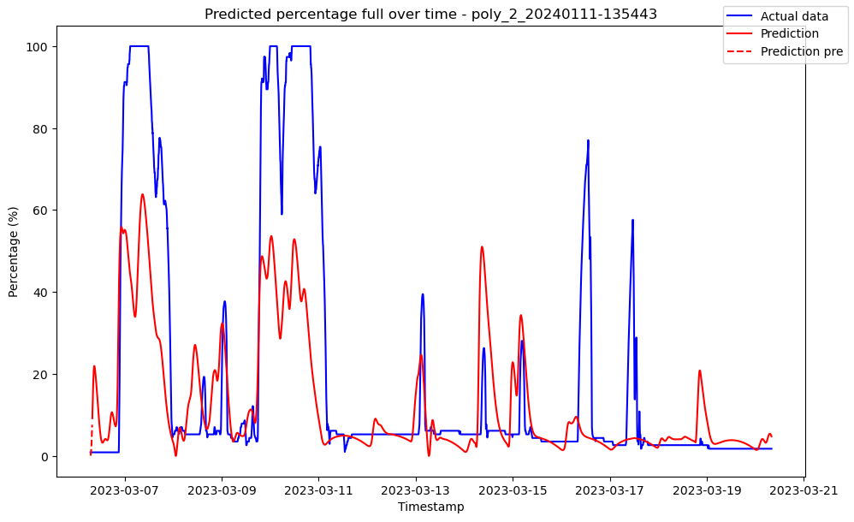

# ------------------------------------ poly_3_20240111-135459 -----------------------------------

Pre-predictions:

timestamp percentage_current rainfall_current

0 2023-03-06 07:05:00 0.056829 0.0

1 2023-03-06 07:10:00 0.167271 0.0

2 2023-03-06 07:15:00 0.303794 0.0

3 2023-03-06 07:20:00 0.444766 0.0

4 2023-03-06 07:25:00 0.584152 0.0

5 2023-03-06 07:30:00 0.720502 0.0

6 2023-03-06 07:35:00 0.845895 0.0

7 2023-03-06 07:40:00 0.959718 0.0

8 2023-03-06 07:45:00 1.066388 0.0

9 2023-03-06 07:50:00 1.170320 0.0

10 2023-03-06 07:55:00 1.273435 0.0

Metrics for this specific prediction:

Accuracy: 99.98%

Mean squared error: 0.18009193037008445

Variance (R²) score: 1.00

# -------------------------- ridge_regression_20240111-142112 --------------------------------

Pre-predictions:

timestamp percentage_current rainfall_current

0 2023-03-06 07:05:00 0.096358 0.0

1 2023-03-06 07:10:00 0.224640 0.0

2 2023-03-06 07:15:00 0.375398 0.0

3 2023-03-06 07:20:00 0.539569 0.0

4 2023-03-06 07:25:00 0.712760 0.0

5 2023-03-06 07:30:00 0.895471 0.0

6 2023-03-06 07:35:00 1.084674 0.0

7 2023-03-06 07:40:00 1.277114 0.0

8 2023-03-06 07:45:00 1.473508 0.0

9 2023-03-06 07:50:00 1.670978 0.0

10 2023-03-06 07:55:00 1.870940 0.0

Metrics for this specific prediction:

Accuracy: 99.97%

Mean squared error: 0.2662739728775895

Variance (R²) score: 1.00

